**ASSESSMENT TOOLS**

To assist with my evaluation of student comprehension of content, I incorporated various means of small informal and formal assessment over the course of the unit. Each class began with a review of the material covered in the previous class. Before adding on any new material, it was important that I knew what students understood and had retained. By reviewing material daily, I was able to assess student comprehension as well as the cognitive domain of the unit content.

In addition to the review at the start of class, I compiled a workbook of assessment tools and homework assignments that were relevant to the concepts covered in class. At the end of each class I would have the students turn these packets into me with their names on them. This ensured two things; first, students were less likely to lose their workbook or assignments when I collected them daily. Second, I was able to individually assess the students after each lesson and plan for the next day accordingly. Though not all material covered throughout the unit was on the pre or post-tests, the homework assignments primarily pertained to the written portion of the unit material. Unfortunately, due to illnesses, family emergencies, and lack of effort on the behalf of a few students, I was not able to assess each student’s progress consistently. Though a few students forgot to turn in or complete some assignments, the majority of students gave a great effort.

Some of the supplemental materials I used for my assessments were:

* “Essentials of Music Theory” Books 1, 2, and 3 – Published by Alfred Publishing
* “Master Theory” Books 1, 2, and 3 – by Charles S. Peters and Paul Yoder
* Various [www.musictheory.net](http://www.musictheory.net) exercises
* “Better Ears” iPhone/iPad app
* “Essential Technique” – by Tom C. Rhodes, Donald Bierschenk, and Tim Lautzenheiser. Published by Hal Leonard

**MUSIC THEORY REFERENCE SHEET**

**Label each key of the piano keyboard, including enharmonic notes.**

🡨 Lower Higher 🡪

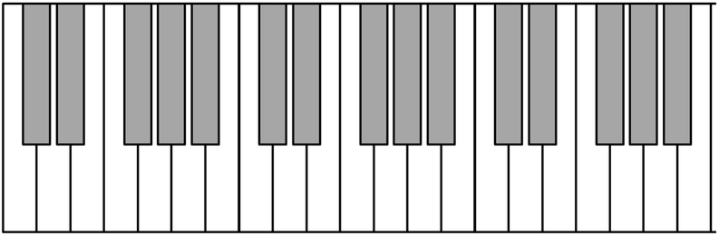

**C**

**Fill in the blanks for each term to complete the definition.**

**SHARPS ______________________** a pitch by a half step. Draw a sharp accidental: ___

**FLATS ______________________** a pitch by a half step. Draw a flat accidental: ___

**NATURALS __________________________** previous sharps and flats in the measure.

Draw a natural accidental: ___

**ENHARMONIC** refers to when a note _______________________________________.

A **HALF STEP** is the distance from one key to the next **______________________** key.

A **WHOLE STEP** is the distance of ______________ half-steps.

**Create acronyms to help you remember the notes of the treble and bass clefs.**

Treble Clef Line Notes:

**E**

**G**

**B**

**D**

**F**

Treble Clef Space Notes:

**F**

**A**

**C**

**E**

Bass Clef Line Notes:

**G**

**B**

**D**

**F**

**A**

Bass Clef Space Notes:

**A**

**C**

**E**

**G**

**Fill in the note names of the line notes and space notes on both the treble and bass clefs.**

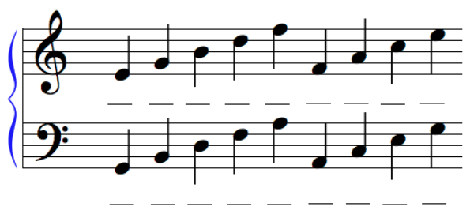

**Day One – Exit Slip**

**Name _______________________ Date _________**

**In 3-5 complete sentences, discuss any terms or concepts that were completely new to you today. Define and describe at least one of these new concepts.**

**OR**

**List and briefly describe 3 terms or concepts we discussed today.**

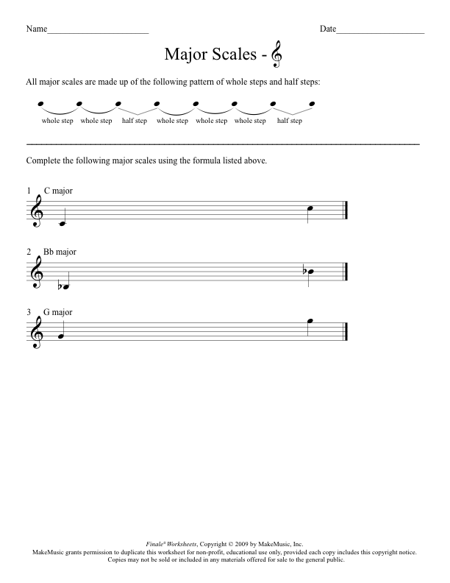

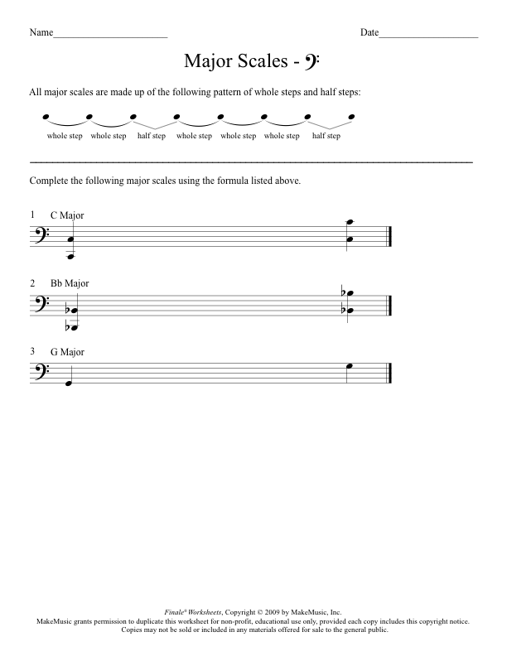

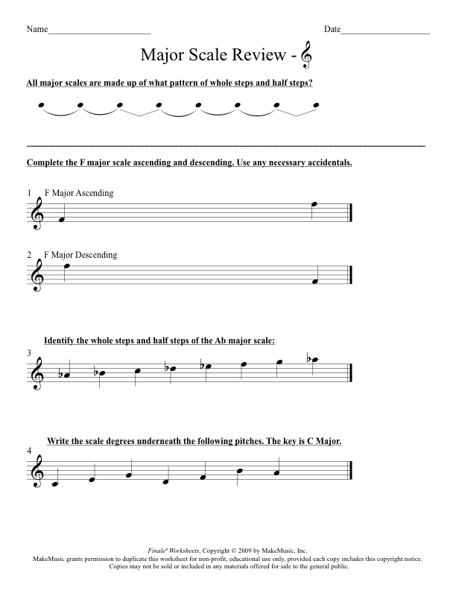

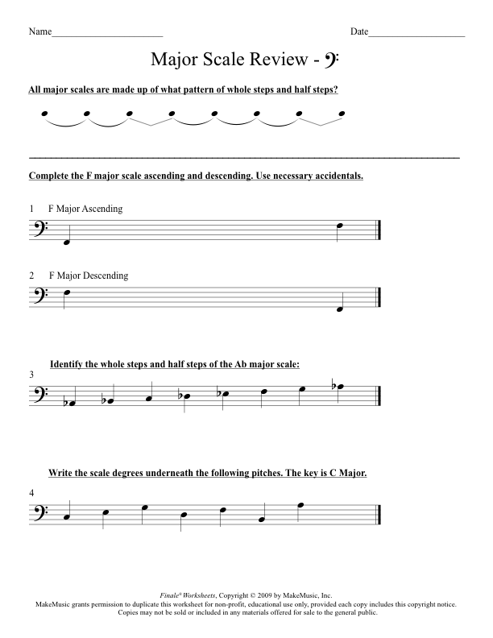

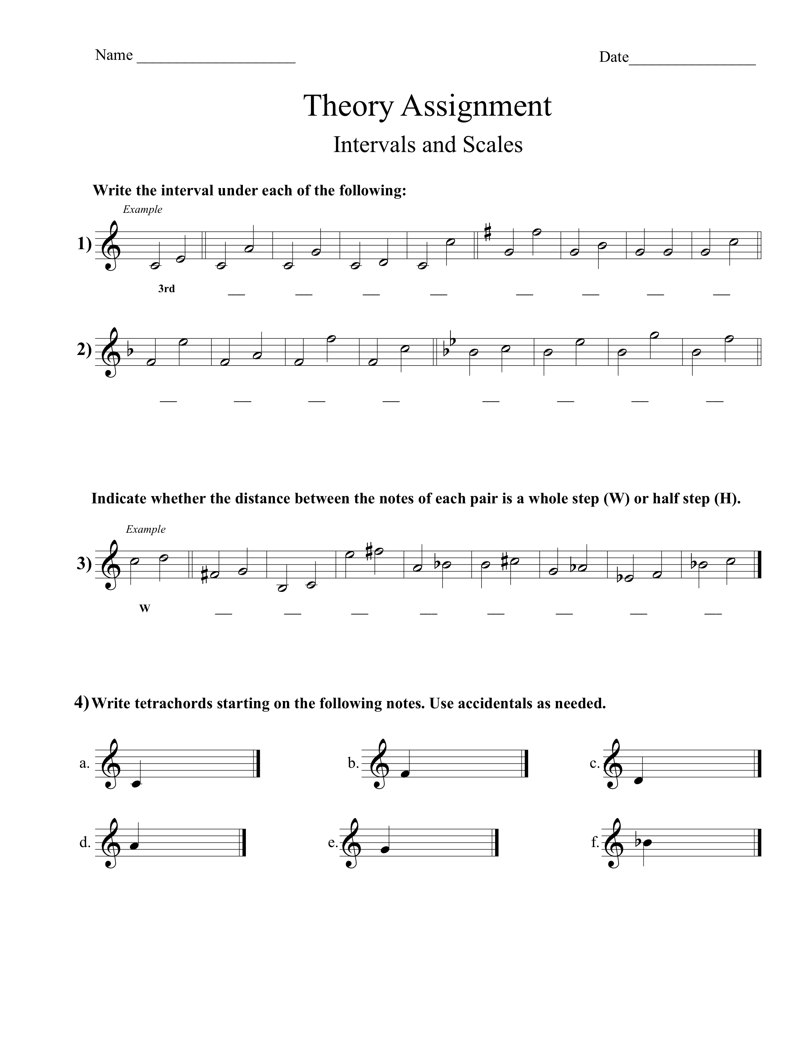

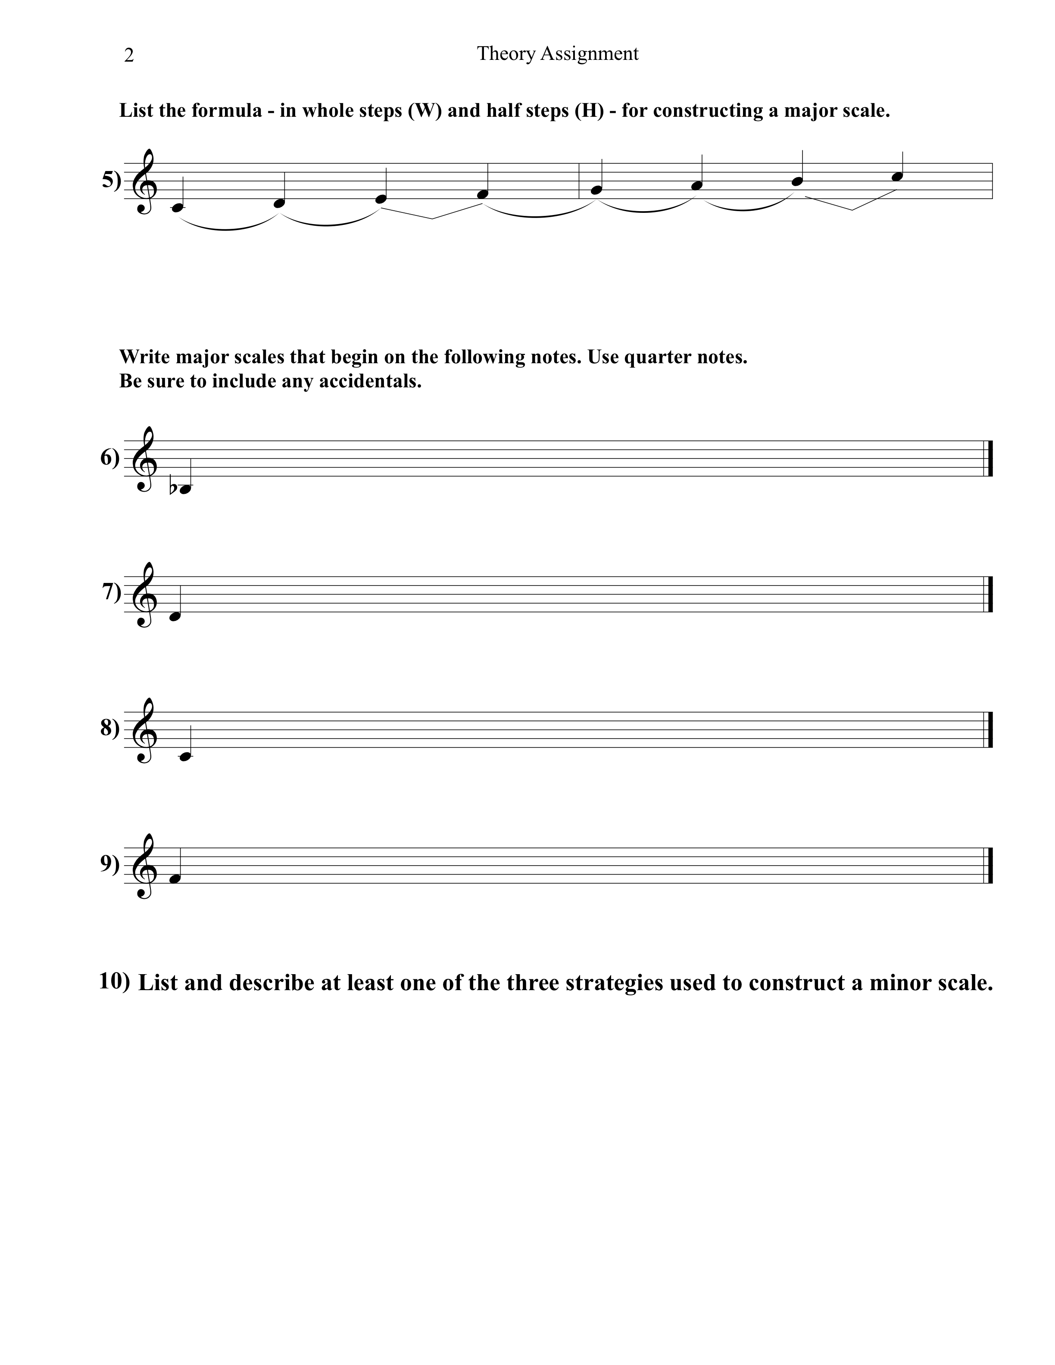

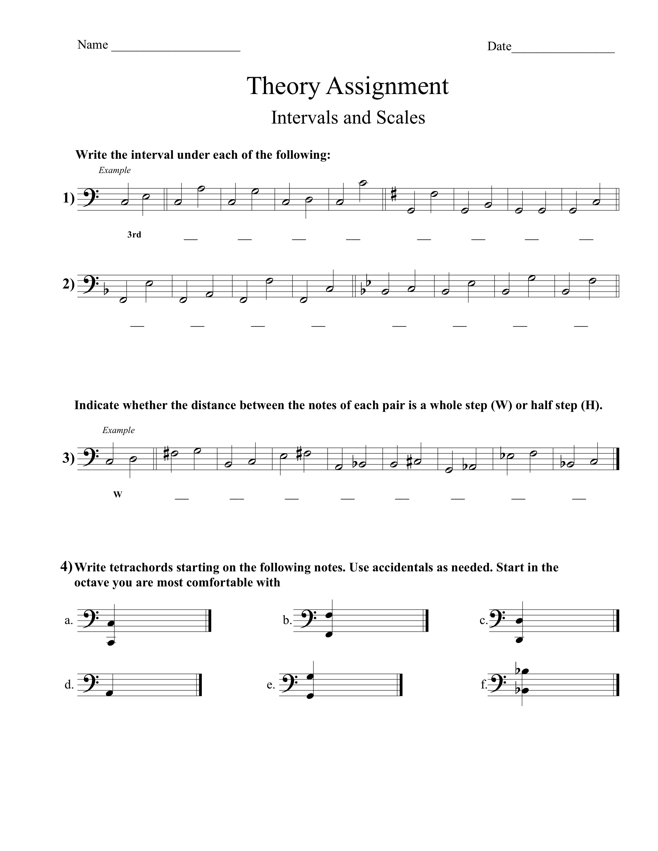

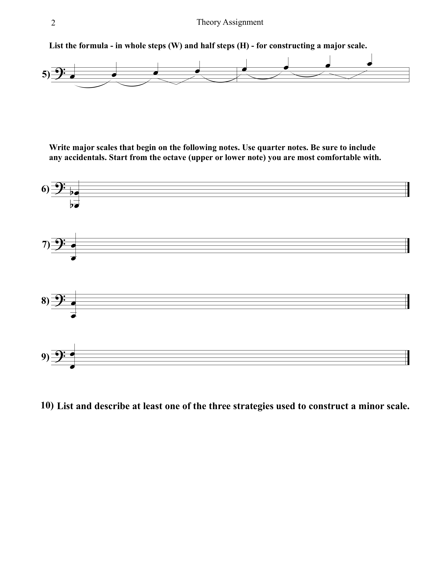

**LAMP – THEORY UNIT**

**POST-TEST STUDY GUIDE**

**Name: ________________________________________ Date: ____________________**

**Aural Identification**

**You will have two questions asking you to listen to an aural example (a scale or a chord followed by an arpeggio) played by the teacher. You will need to identify whether it is MAJOR or minor in quality. Use the following links to practice.**

1. Go to the following link and practice assessing whether the scales are MAJOR or minor in quality (4 pts):

[**http://www.musictheory.net/exercises/ear-scale/dyybyyngney**](http://www.musictheory.net/exercises/ear-scale/dyybyyngney)

1. Go to the following link and practice assessing whether the chords are MAJOR or minor in quality (4 pts):

[**http://www.musictheory.net/exercises/ear-chord/dyyyeyyngney**](http://www.musictheory.net/exercises/ear-chord/dyyyeyyngney)

**Written Test**

1. 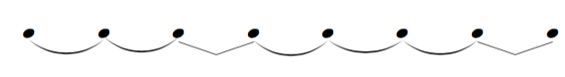What is the pattern, or formula, for writing a Major scale (in half steps **H** and whole steps **W**)? (7 pts)
2. Using the clef you are most comfortable with (treble or bass), write the following scales ASCENDING and DESCENDING on the staff below. You may include either the accidentals or the key signature. Use the concert pitches, not your transposition. (4 pts each)

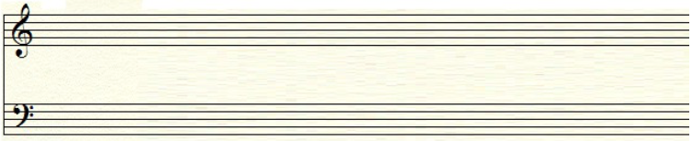**C Major**

**F Major**



1. Using the line with the clef you normally use, write the scale degree for each note on the lines provided below. The key is C major. (7 pts)

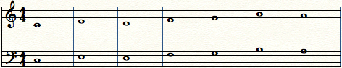

_______ _______ _______ _______ _______ _______ _______

1. Using the line with the clef you normally use, identify the intervals in each measure and write it in the space below. Your options are: Unison, Octave, Half step, Whole step, Third, Fourth, or Fifth. Each option will only be used once. (7 pts)

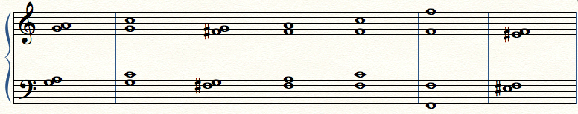

_______ _______ _______ _______ _______ _______ _______

1. Underneath each measure is the name of an interval. In the staff, write the interval above the note. Use the line with the clef you normally use. Please use accidentals if needed. (5 pts)

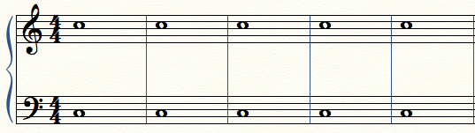

**Fifth | Whole step | Third | Half step | Fourth**

1. Using the line with the clef you normally use, determine whether the following chords in each measure are MAJOR chords or minor chords. (4 pts)

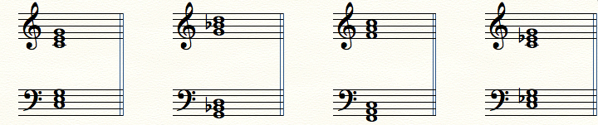

______________ ______________ ______________ ______________

**The following questions are multiple choice. Please choose the item that most accurately answers the question. (2 pts)**

1. What change must be made to a MAJOR chord to make it a minor chord?
   1. Raise the fifth a minor second
   2. Lower the third a half step
   3. Lower the root a whole step
   4. Add the seventh
2. Enharmonic notes are notes _______________.
   1. That are played on black keys
   2. With accidentals
   3. That are out of tune
   4. With multiple spellings

**The following questions are true/false. If false, please explain why the answer is false in the space below. Please use full sentences. (2 pts)**

1. A sharp accidental (#) LOWERS a pitch by a half step. (1 pt)
   1. True
   2. False
2. A flat accidental (b) LOWERS a pitch by a whole step. (1 pt)
   1. True
   2. False

***Total Points* _____________ / _____________**