Aural Identification

Listen to the aural example (a scale or a chord followed by an arpeggio) played by the teacher and identify whether it is MAJOR or minor in quality. Each example will be played a total of 3 times.

- Identify whether the following scale played is MAJOR or minor in quality. (4 pts)

  - __________________

  - __________________

  - __________________

  - __________________

- Identify whether the chord being played is MAJOR or minor in quality. (4 pts)

  - __________________

  - __________________

  - __________________

  - __________________
Written Test

- What is the pattern, or formula, for writing a Major scale (in half steps H and whole steps W)? (7 pts)

______ ______ ______ ______ ______ ______ ______

- Using the clef you are most comfortable with (treble or bass), write the following scales ASCENDING and DESCENDING on the staff below. You may include either the accidentals or the key signature. Use the concert pitches, not your transposition. (4 pts each)
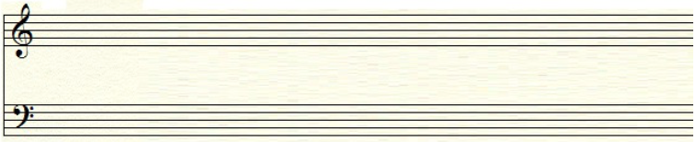
C Major

F Major

- Using the line with the clef you normally use, write the scale degree for each note on the lines provided below. The key is C major. (7 pts)
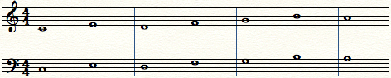

________ ________ ________ ________ ________ ________ ________

- Using the line with the clef you normally use, identify the intervals in each measure and write it in the space below. Your options are: Unison, Octave, Half step, Whole step, Third, Fourth, or Fifth. Each option will only be used once. (7 pts)

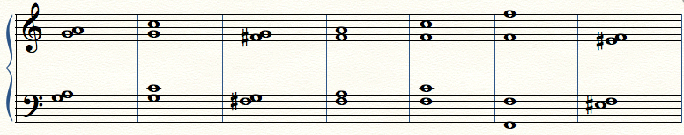

________ ________ ________ ________ ________ ________ ________

- Underneath each measure is the name of an interval. In the staff, write the interval above the note. Use the line with the clef you normally use. Please use accidentals if needed. (5 pts)

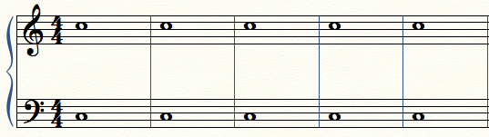

Fifth | Whole step | Third | Half step | Fourth

- Using the line with the clef you normally use, determine whether the following chords in each measure are MAJOR chords or minor chords. (4 pts)

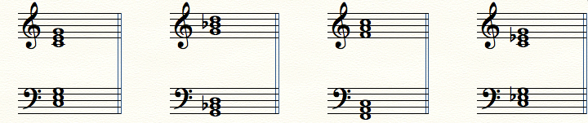

_____________________ _____________________ _____________________ _____________________

The following questions are multiple choice. Please choose the item that most accurately answers the question. (2 pts)

- What change must be made to a MAJOR chord to make it a minor chord?

  - Raise the fifth a minor second

  - Lower the third a half step
  - Lower the root a whole step

  - A balanced diet consisting of fruits and vegetables

- Enharmonic notes are notes _______________.

  - That are played on black keys

  - With accidentals

  - That are out of tune

  - With multiple spellings

The following questions are true/false. If false, please explain why the answer is false in the space below. Please use full sentences. (2 pts)

- A sharp accidental (#) RAISES a pitch by a whole step. (1 pt)
  - True
  - False

- A flat accidental (b) LOWERS a pitch by a half step. (1 pt)
  - True
  - False

Total Points _____________ / _____________

